Why great power demands great responsibility
By Fai-nan Perng | Published: 02 January, 2014
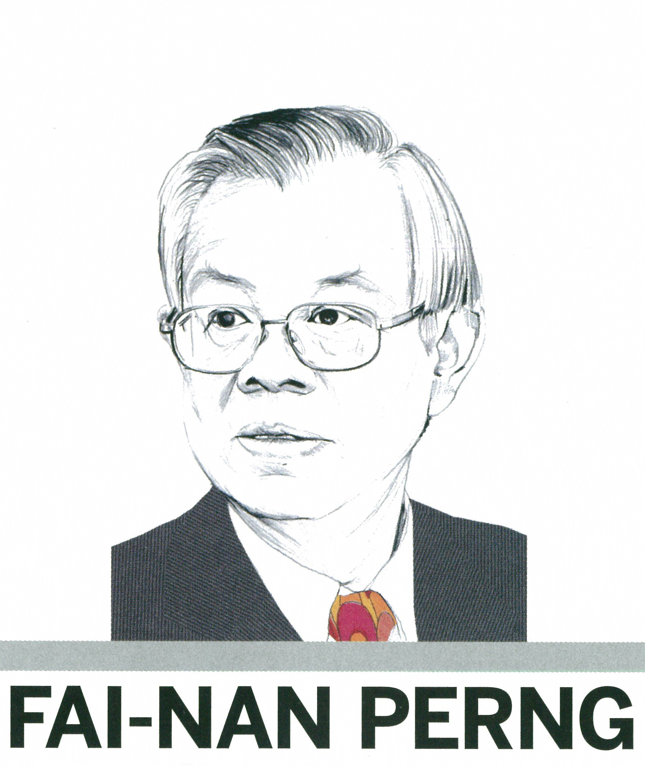

Advanced economies such as the US and the eurozone enjoy enormous privilege as issuers of international currencies, says Taiwan’s central bank governor. This power needs to be tempered with a responsibility to promote economic stability on a global scale.

The global financial crisis that broke out in late 2008 has cast a long shadow over the world’s economy. The severity of the downturn that immediately followed is surpassed only by the Great Depression of the 1930s. To make matters worse, Greece came to the fore in October 2009 as the curtain raiser for the European debt crisis. This generation of central bankers has never faced greater uncertainty than in the past five years.

During this turbulent period, a number of advanced economies have become heavily dependent on the unusually accommodating monetary policy that has been deployed to support stock prices, real-estate markets and inflation expectations. Very low interest rates and asset purchase programmes implemented by these countries have indirectly pushed down the exchange rates of these countries as part of the stimulus package designed to shore up aggregate demand and economic growth.

This unconventional monetary policy was perhaps warranted during the height of the financial crisis as it averted the collapse of the global financial system and provided a lifeline to economies. However, some of these countries happen to be issuers of international currencies. Monetary policy thus becomes one of their greatest exports. While the overall benefit their policy can bring to the global economy remains to be seen, there is little doubt its massive spillover effect has already seriously disrupted global financial markets.

Economies in decline

The share of advanced economies in global output has been in steady decline and their business cycles have become increasingly out of sync with the rest of the world. Yet, because of the role played by international currencies in global trade and international financial markets, monetary policy implemented by these countries can be transmitted to emerging markets with unintended and undesirable consequences.

In many instances, accommodative domestic policies are exported unwittingly to overheated foreign markets, thus fuelling asset bubbles and threatening economic and financial stability.

The impact of monetary policy adopted by advanced economies is transmitted to the financial markets of less developed countries through short-term international capital movements, where portfolio and speculative flows of capital can distort the intrinsic value of currencies. The effect is particularly acute for small and highly open economies such as Taiwan, Singapore and Hong Kong, where the exchange rate plays a large role in economic and financial stability.

Let us look at Taiwan. As a group, foreign portfolio investors have become a major force in both the equity and foreign exchange markets since the early 1990s. There are currently more than 6700 registered foreign portfolio investors in Taiwan. Collectively, they account for 36% of the turnover in the interbank foreign exchange market. The 20 most active players are responsible for the bulk of foreign exchange transactions undertaken by all foreign portfolio investors. At the end of June 2013, the combined market value of stocks, bonds and local currency deposits held by foreign portfolio investors came to $228.5bn, the equivalent of 56% of Taiwan’s international reserves. It is not difficult to see how short-term international capital movements have become the main driver of the exchange rate of the new Taiwan dollar.

Overshooting the mark

Currency allocation decisions made by foreign investors tend to rely on common but narrow and fickle information sources. They jointly become a seller of foreign exchange one day and a buyer the next day. Their trading strategy, driven by asymmetric and incomplete information, leads to a herding behaviour that constantly and dramatically shifts the demand and supply curves. As a result, the exchange rate has a tendency to overshoot and misalign with economic fundamentals, undermining financial and economic stability in the host country.

Communication, as a tool, has increasingly been used by some central banks to buttress the effectiveness of monetary policy. Formal statements drafted by top officials or casual remarks delivered by senior political leaders can trigger changes in risk-on/risk-off sentiments that sway global financial markets. The problem is made worse when members of the same institution express opposing views on the same subject, creating noises that amplify market volatility.

Emerging markets in the Asia-Pacific region are often at the receiving end of these destabilising forces. During the month of June 2013, as stock markets around the world went through a major correction phase, six Asian economies collectively experienced a net capital outflow of some $14.3bn. Investor sentiments then changed rapidly a couple of weeks later when we saw the share of foreign portfolio investors in Taiwan’s foreign exchange market turnover shoot up from 22% on July 9 to 34% the next day, eventually peaking at 39% on July 15. This sauna-like effect was inextricably linked to comments made by senior government officials in advanced countries in the same timeframe. Reaction to such an ‘announcement effect’ produces market volatility and puts other economies at risk.

Spillover effects

The international spillover effects created by the unconventional monetary policy have also been widely discussed at the 2013 Economic Policy Symposium in Jackson Hole, Wyoming. In particular, the paper presented by Professor Hélène Rey finds that monetary policy in the ‘centre country’ is a major determinant of the global financial cycle. Gross capital flows around the world, in turn, are closely linked to the global financial cycle, which is not aligned with the recipient country’s macroeconomic fundamentals.

The possible side-effects of unconventional monetary policy, therefore, include excess credit creation and large asset price bubbles in someone else’s backyard. The paper further points out that the global financial cycle constrains monetary policy in countries with liberalised capital accounts, regardless of the choice of exchange rate regime. In other words, monetary policy independence is only attainable when the capital account is managed.

Policy uncertainty

Apart from monetary policy per se, the huge policy uncertainty in some advanced nations also has a significant spillover effect, as outlined by the International Monetary Fund (IMF) in the 2013 Spillover Report – Analytical Underpinnings and Other Background. The IMF identifies a number of policy events in the US and Europe that have created so much uncertainty, undermining not only domestic economic growth but also global investment momentum through spillover effects. Such events include the debt ceiling row in 2011, the related fiscal cliff debate the next year and the manner in which the European debt crisis was handled throughout 2012.

In June 2009, US president Barack Obama spoke about the global financial crisis: “Inadequate regulation, coupled with a vast culture of greed and an explosion of complicated financial instruments, induced excessive risk-taking and helped trigger the economic crisis.” Whether stock market capitalism has disconnected financial market development from economic fundamentals and whether the recent monetary policy adopted by some countries has inadvertently contributed to this trend are questions that beg answers.

There's no such thing as a free lunch, as economist Milton Friedman put it. Monetary policy that depends on the stock market to provide on and off short-term stimulus can neither foster long-term economic development nor promote global financial stability. For individual countries, a viable economic revitalisation programme entails strengthening financial supervision, improving the standard of education and raising the level of productivity.

Only by focusing on improving fundamentals can an economy reach full potential and stay on a sustainable path. From a global perspective, major advanced countries enjoy, to varying degrees, exorbitant privilege as issuers of international currencies. Monetary policy formulated by these countries has a disproportionally large impact on global financial markets.

With great power comes great responsibility; the burden of promoting global economic and financial stability rests squarely on the shoulders of the central bankers in these countries. This understanding is the foundation on which healthy global economic development must be built.

Fai-nan Perng is governor of the Central Bank of the Republic of China (Taiwan).

