Condition and Performance of Domestic Banks

First Quarter 2020

Summary of condition and performance
As of end-Mar. 2020, there were 37 domestic banks with 3,410 branches and 36 off-shore banking units in Taiwan. The largest banks were Bank of Taiwan, CTBC Bank Co., Ltd. and Taiwan Cooperative Bank in terms of assets, while the largest banks in terms of the net income before tax for the first quarter of 2020 were CTBC Bank Co., Ltd., Cathay United Bank and E. Sun Com. Bank, Ltd.
The average capital adequacy ratio of domestic banks was well above the regulatory requirement of 10.5% as of end-Mar. 2020, indicating that capital adequacy kept satisfactory. Asset quality remained sound and loan loss provisions were sufficient to cover potential losses. The profitability for domestic banks weakened for the first quarter of 2020, while liquidity kept ample with the liquidity related ratios well above the regulatory requirement.

Key trend
As of end-Mar. 2020, total assets and liabilities of domestic banks amounted to NT$53,261.8 billion and NT$49,242.5 billion, increasing by 2.31% and 2.50%, respectively, while total equity almost remained the same at NT$4,019.3 billion, compared to end-Dec. 2019. Domestic banks as a whole posed a net income before tax of NT$81.3 billion for the first quarter of 2020, significantly decreasing by NT$16.6 billion or -16.96%, compared to the same period of previous year. The major income statement components are tabulated as follows:

Major Income Statement Components
Unit: NT$ Billion
 | 2019 Q1 | 2020 Q1 | Change%
Income
Net interest income | 117.7 | 122.2 | 3.82
Net income other than interest | 100.1 | 74.2 | -25.87
Expense
Loan loss provision | 13.9 | 10.4 | -25.18
Other expenses | 106.0 | 104.7 | -1.23
Loss from discontinued operations  Net income before tax | -  97.9 | -  81.3 | -  -16.96

Net interest income slightly increased
Net interest income reported NT$122.2 billion for the first quarter of 2020, increasing by NT$0.7 billion or 0.58% compared to the previous quarter (Chart 1).

Chart 2
Deposits
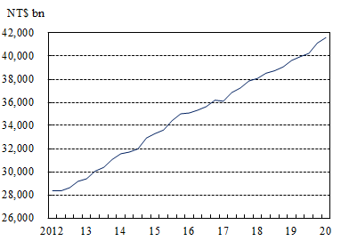
Note: Data are on a quarterly basis.
Deposits saw stable growth
Total deposits amounted to NT$41,600.4 billion as of end-Mar. 2020, increasing by NT$471.2 billion or 1.15% compared to end-Dec. 2019 (Chart 2). The annual growth rate of deposits was 4.40%, decreasing by 0.14 percentage points compared to the previous quarter.

Loans kept on rising
Chart 3
Loans
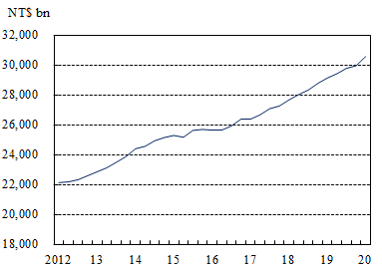
Note: Data are on a quarterly basis.
Total loans stood at NT$30,579.9 billion as of end-Mar. 2020, rising by NT$616.9 billion or 2.06% compared to end-Dec. 2019 (Chart 3). The annual growth rate of loans registered 4.91%, increasing by 1.23 percentage points compared to the previous quarter.

Investments increased moderately
Chart 4
Investments
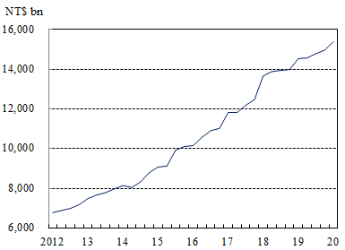
Note: Data are on a quarterly basis.
Total investments mounted to NT$15,392.3 billion as of end-Mar. 2020, increasing by NT$425.1 billion or 2.84% compared to end-Dec. 2019 (Chart 4). The annual growth rate of investment reached 3.11%, declining by 3.43 percentage points compared to the previous quarter.

Chart 1
Net interest income
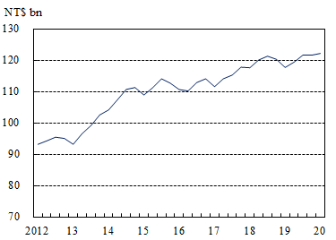
Note: Data are on a quarterly basis.

Asset quality kept satisfactory
Chart 5
NPL ratio
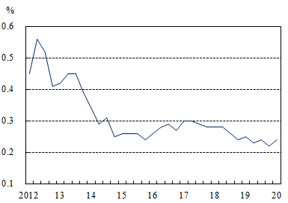
Notes:1.Data are on a quarterly basis.
2.Data are arithmetic mean.

The average non-performing loan (NPL) ratio was 0.24% as of end-Mar. 2020, increasing by 0.02 percentage points compared to end-Dec. 2019 (Chart 5). However, the asset quality of domestic banks kept satisfactory.

NPL coverage ratio declined mildly
Chart 6
NPL coverage ratio
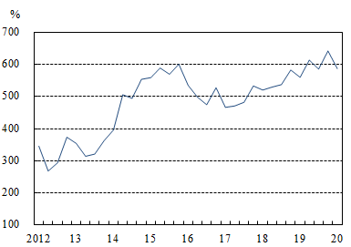
Note: Data are on a quarterly basis.
The average NPL coverage ratio stood at 587.29% as of end-Mar. 2020, down by 55.77 percentage points compared to end-Dec. 2019 (Chart 6). Nevertheless, the capability of domestic banks to cope with potential loan losses remained solid.

Liquidity coverage ratio decreased slightly
Chart 7
Liquidity coverage ratio
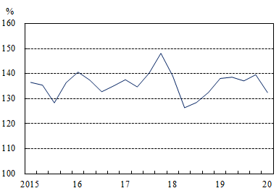
Notes:1.Data are on a quarterly basis.
2.Data are disclosed since 2015.

The average liquidity coverage ratio (LCR) was 132.46% as of end-Mar. 2020, with a decline of 7.15 percentage points in the first quarter (Chart 7). Every domestic bank met the minimum LCR requirement.

Capital adequacy ratio remained sound
Chart 8
Capital adequacy ratio
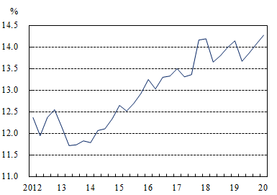
Notes:1.Data are on a quarterly basis.
2.Data are arithmetic mean.
The average capital adequacy ratio was 14.27% as of end-Mar. 2020, increasing by 0.20 percentage points compared to end-Dec. 2019 (Chart 8). The capital adequacy for domestic banks remained sound as the capital adequacy ratio of every domestic bank was well above the regulatory requirement of 10.50%.

