Condition and Performance of Domestic Banks

Third Quarter 2017

Summary of condition and performance
As of end-Sep. 2017, there were 39 domestic banks with 3,425 branches and 38 off-shore banking units in Taiwan. The largest banks were Bank of Taiwan, Mega International Commercial Bank and Taiwan Cooperative Bank in terms of assets, while the largest banks in terms of the net income before tax for the first three quarters of 2017 were CTBC Bank Co., Ltd, Mega International Commercial Bank and Cathay United Bank.
As of end-Sep. 2017, the domestic banks as a whole the average capital adequacy ratio was well above the regulatory requirement of 9.25%, indicating that capital adequacy for domestic banks kept satisfactory. Asset quality remained sound and the provisions for loans were sufficient to cover potential losses. The profitability for domestic banks remains stable for the first three quarter of 2017 while liquidity kept ample with the liquidity ratio well above the regulatory requirement of 10%.

Key trend
As of end-Sep. 2017, domestic banks total assets and liabilities amounted to NT$47,052.3 billion and NT$43,599.1 billion, increasing by NT$727.0 billion and NT$ 642.0 billion or 1.57% and 1.49%, respectively, compared to end-Jun. 2017. Total equities amounted to 3,453.2 billion increasing by NT$ 85.0 billion or 2.52% compared to end-Jun. 2017. Domestic banks as a whole posed a net income before tax of NT$247.3 billion for the three quarters of 2017, increasing by NT$ 8.0 billion or 3.34% compared to the same period of previous year. The major income statement components are tabulated as follows:

Major Income Statement Components
Unit: NT$ Billion
 | Jan.-Sep.  2016 | Jan.-Sep.  2017 | Change%
Income
Net interest revenues | 333.8 | 341.1 | 2.19
Net revenues other than interest | 231.6 | 231.5 | -0.04
Expense
Loan loss provision | 34.1 | 25.6 | -24.93
Other expense | 292.0 | 299.5 | 2.57
Loss from discontinued operations  Net income before tax | 0  239.3 | 0.2  247.3 | -  3.34

Net interest revenues increased
Chart 1
Net interest revenues
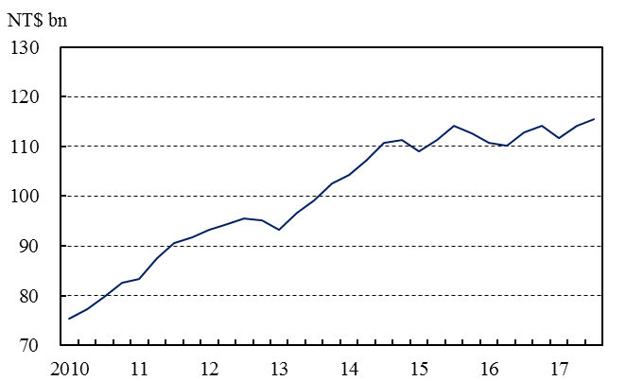
Note: Data are on a quarterly basis.
Net interest revenues reported NT$115.3 billion for 2017Q3, increasing by NT$1.2 billion or 1.05% compared to the previous quarter (Chart 1).

Chart 2
Deposits
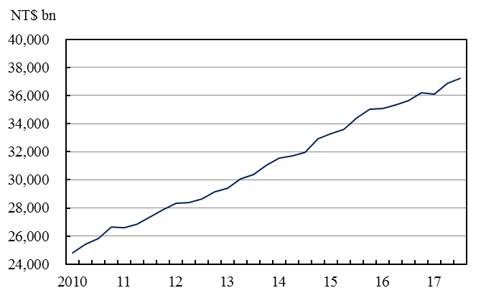
Note: Data are on a quarterly basis.
Deposits increased
Total deposits amounted to NT$37,243.5 billion as of end-Sep. 2017, increasing by NT$394.7 billion or 1.07% compared to end-Jun. of 2017 (Chart 2). The annual growth rate of deposits was 4.28% as of end-Sep. 2017, decreasing by 0.54 percentage points compared to the previous quarter.

Loans increased
Chart 3
Loans
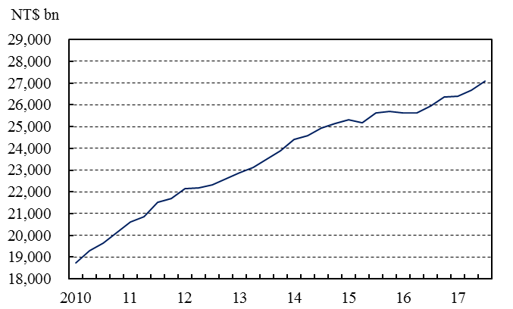
Note: Data are on a quarterly basis.
Total loans amounted to NT$27,084.5 billion as of end-Sep. 2017, increasing by NT$400.6 billion or 1.50% compared to end-Jun. of 2017 (Chart 3). The annual growth rate of loans registered 5.23% as of end-Sep. 2017, increasing by 0.70 percentage points compared to the previous quarter.

Investments increased
Chart 4
Investments
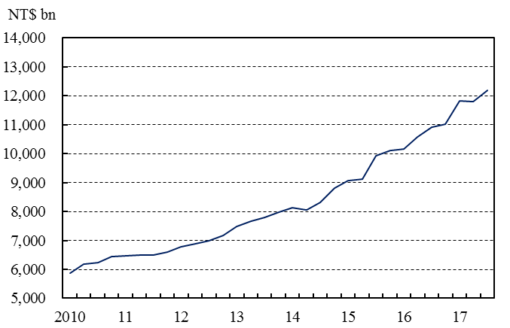
Note: Data are on a quarterly basis.
Total investments amounted to NT$12,191.2 billion as of end-Sep. 2017, increasing by NT$378.8 billion or 3.21% compared to end-Jun. of 2017 (Chart 4). The annual growth rate of investment reached 13.99% as of end-Sep. 2017, decreasing by 6.03 percentage points compared to the previous quarter.

Asset quality remained satisfactory
The average NPL ratio stood at 0.29% as of end-Sep. 2017, decreasing by 0.01 percentage points compared to end-Jun. 2017 (Chart 5). Asset quality for the overall banking sector kept satisfactory. The average provision coverage ratio was 482.51%, increasing by 11.45 percentage points compared to end-Jun. 2017.

Chart 6
Provision-to-loan ratio
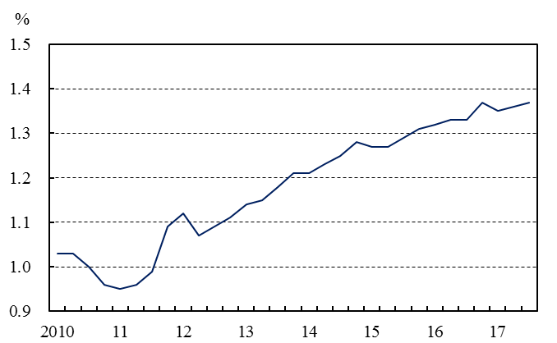
Note: Data are on a quarterly basis.
Provision-to-loan ratio increasing
The average provision-to-loan ratio was 1.37% as of end-Sep. 2017, increasing by 0.01 percentage points compared to end-Jun. 2017 (Chart 6).

Chart 7
Liquidity ratio
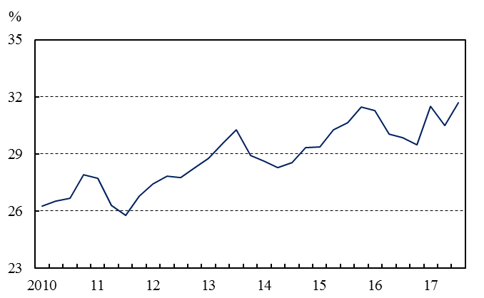
Note: Data are on a quarterly basis.
Liquidity kept ample
The average liquidity ratio was 31.69% for domestic banks as a whole in Sep. 2017, increasing by 1.20 percentage points compared to that in Jun. 2017 (Chart 7). Every domestic bank met the regulatory liquidity ratio requirement of 10%. Liquidity for domestic banking sector kept ample.

Chart 8
Capital adequacy ratio
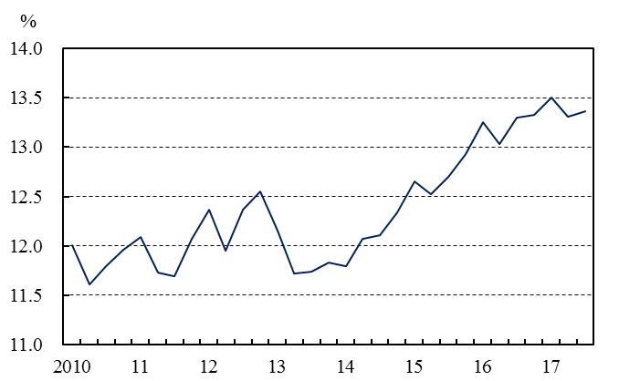
Note: Data are on a quarterly basis.
Average capital adequacy remained satisfactory
Chart 5
NPL ratio
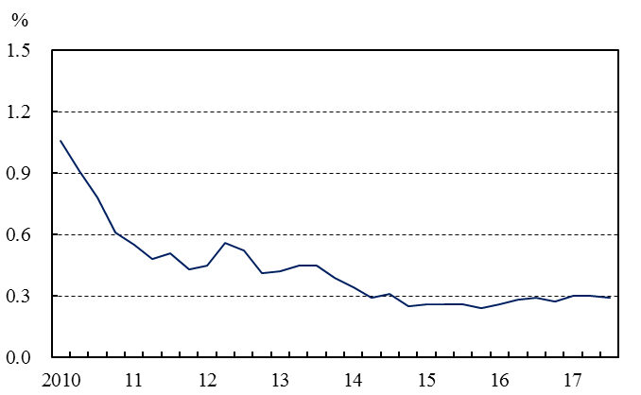
Note: Data are on a quarterly basis.
The average capital adequacy ratio was 13.36% as of end-Sep. 2017, increasing by 0.05 percentage points compared to end-Jun. 2017 (Chart 8). The capital adequacy for domestic banks as a whole remained satisfactory as the capital adequacy ratio of every domestic bank was well above the regulatory requirement of 9.25%.

