Condition and Performance of Domestic Banks

Second Quarter 2019

Summary of condition and performance
As of end-Jun. 2019, there were 37 domestic banks with 3,406 branches and 36 off-shore banking units in Taiwan. The largest banks were Bank of Taiwan, Taiwan Cooperative Bank and CTBC Bank Co., Ltd. in terms of assets, while the largest banks in terms of the net income before tax for the first half of 2019 were CTBC Bank Co., Ltd., Mega International Commercial Bank and Cathay United Bank.
As of end-Jun. 2019, the domestic banks as a whole the average capital adequacy ratio was well above the regulatory requirement of 10.5% indicating that capital adequacy for domestic banks kept satisfactory. Asset quality remained sound and the provisions for loans were sufficient to cover potential losses. The profitability for domestic banks remains stable for the first half of 2019 while liquidity kept ample with the liquidity ratio well above the regulatory requirement of 10%.

Key trend
As of end-Jun. 2019, domestic banks' total assets and liabilities amounted to NT$51,067.8 billion and 47,238.8 billion, increasing by NT$352.8 billion and NT$390.4 billion or 0.70% and 0.83%, respectively, compared to end-Mar. 2019. Total equity amounted to NT$3,829.0 billion decreasing by NT$37.6 billion or 0.97% compared to end-Mar. 2019. Domestic banks as a whole posed a net income before tax of NT$193.7 billion for the first half of 2019, increasing by NT$17.1 billion or 9.68% compared to the same period of previous year. The major income statement components are tabulated as follows:

Major Income Statement Components
Unit: NT$ Billion
 | Jan.-Jun.  2018 | Jan.-Jun.  2019 | Change%
Income
Net interest income | 237.7 | 237.1 | -0.25
Net income other than interest | 163.7 | 191.2 | 16.80
Expense
Loan loss provision | 20.0 | 22.7 | 13.50
Other expenses | 204.7 | 211.9 | 3.52
Loss from discontinued operations  Net income before tax | 0.1  176.6 | -  193.7 | -100.00  9.68

Net interest income slightly increased
Net interest income reported NT$119.4 billion for 2019Q2, increasing by NT$1.7 billion or 1.44% compared to the previous quarter (Chart 1).

Chart 2
Deposits
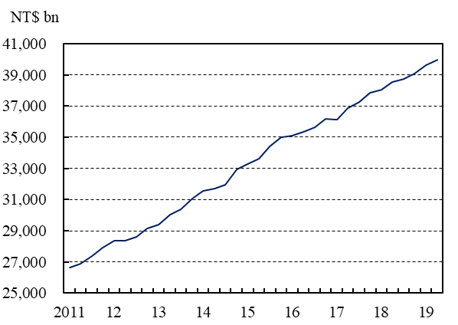
Note: Data are on a quarterly basis.
Deposits saw stable growth
Total deposits amounted to NT$39,954.8 billion as of end-Jun. 2019, increasing by NT$319.5 billion or 0.81% compared to end-Mar. of 2019 (Chart 2). The annual growth rate of deposits was 3.43% as of end-Jun. 2019, decreasing by 0.38 percentage points compared to the previous quarter.

Loans kept on rising
Chart 3
Loans
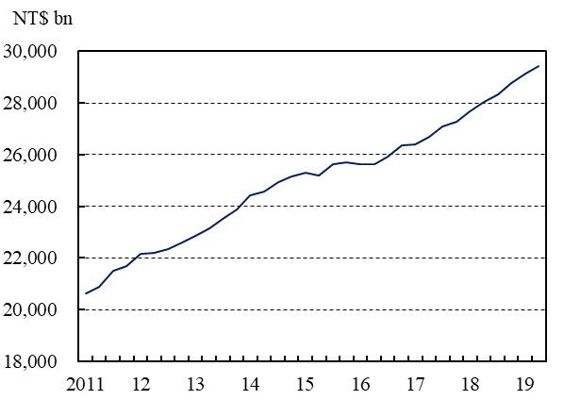
Note: Data are on a quarterly basis.
Total loans amounted to NT$29,427.9 billion as of end-Jun. 2019, increasing by NT$280.1 billion or 0.96% compared to end-Mar. of 2019 (Chart 3). The annual growth rate of loans registered 3.85% as of end-Jun. 2019, decreasing by 1.07 percentage points compared to the previous quarter.

Investments increased mildly
Chart 4
Investments
Note: Data are on a quarterly basis.
Total investments amounted to NT$14,577.4 billion as of end-Jun. 2019, increasing by NT$37.2 billion or 0.26% compared to end-Mar. of 2019 (Chart 4). The annual growth rate of investment reached 6.32% as of end-Jun. 2019, increasing by 1.08 percentage points compared to the previous quarter.

Chart 1
Net interest income
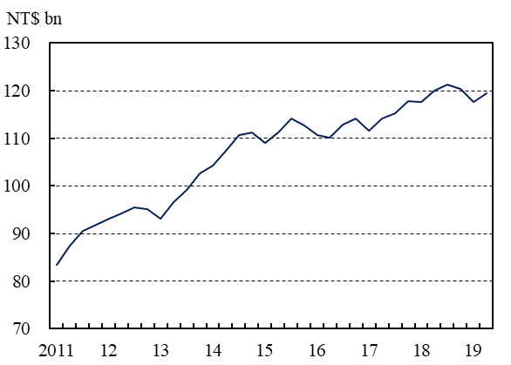
Note: Data are on a quarterly basis.

Asset quality kept satisfactory
Chart 5
NPL ratio
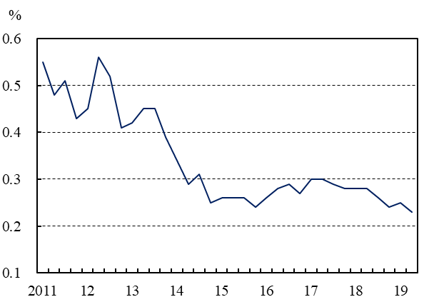
Note:1.Data are on a quarterly basis.
2.Data are arithmetic mean.

The average NPL ratio was 0.23% as of end-Jun. 2019, decreasing by 0.02 percentage points compared to end-Mar. 2019 (Chart 5). The asset quality of domestic banks kept satisfactory.

Chart 6
NPL coverage ratio
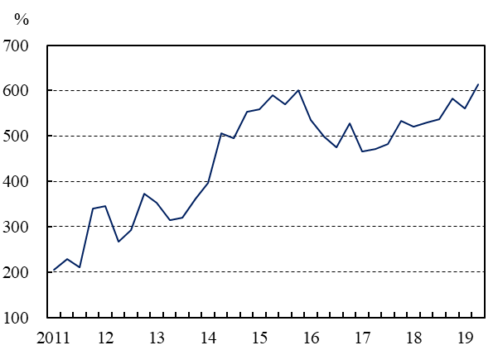
Note: Data are on a quarterly basis.
NPL coverage ratio increased slightly
The NPL coverage ratio stood at 614.06%, increasing by 53.81 percentage points compared to end-Mar. 2019 (Chart 6). The capability of domestic banks to cope with potential loan losses remained satisfactory.

Liquidity remained ample
Chart 7
Liquidity reserve ratio
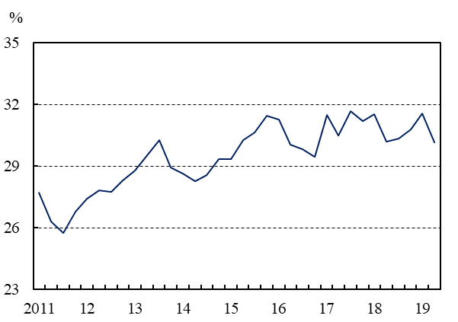
Note: Data are the average daily data in the last month of each quarter.
The average liquidity reserve ratio was 30.14% for domestic banks as a whole in Jun. 2019, decreasing by 1.44 percentage points compared to that in Mar. 2019 (Chart 7). Every domestic bank met the regulatory liquidity ratio requirement of 10%. The overall liquidity of domestic banks remained abundant.

Average capital adequacy ratio remained satisfactory
Chart 8
Average capital adequacy ratio
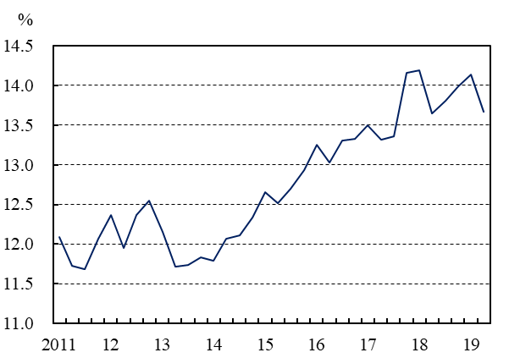
Note:1.Data are on a quarterly basis.
2.Data are arithmetic mean.
The average capital adequacy ratio was 13.67% as of end-Jun. 2019, decreasing by 0.47 percentage points compared to end-Mar. 2019 (Chart 8). The capital adequacy for domestic banks as a whole remained satisfactory as the capital adequacy ratio of every domestic bank was well above the regulatory requirement of 10.50%.

